|  |
| --- |
| Circle Language Spec: Inheritance |

## Interface Inheritance

Since any redirection of a triangle is considered inheritance, interface redirection of a triangle may also be called inheritance: *interface inheritance*.

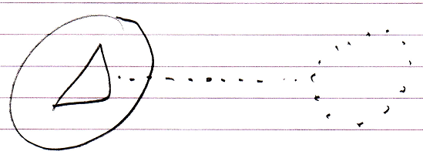

So the main concept of inheritance is basically the same as that of interfaces.